YEAR 7 SCIENCE
Chemistry End of Topic Test

NAME: Mark: /50

Select the best answer for the following questions and circle your answer clearly in the table provided.

 | Circle the correct answer
1 | A B C D
2 | A B C D
3 | A B C D
4 | A B C D
5 | A B C D
6 | A B C D
7 | A B C D
8 | A B C D
9 | A B C D
10 | A B C D
1. Which of the following can a sieve not be used for?

(a) separating solids and liquids.
(b) separating solutes and solvents
(c) separating solids of different sizes
(d) it can be used for all of the above.

2. Milk is a mixture of fat mixed through water. The fat does not settle out easily. Milk is an example of:

(a) a solution.
(b) a suspension
(c) a colloid
(d) a solute

3. The process used in the diagram to the right is called:
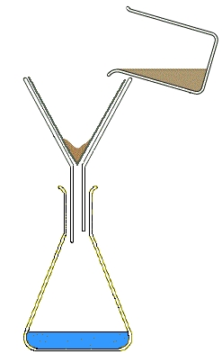

(a) filtration.
(b) evaporation.
(c) decantation.
(d) boiling.

4. A substance is insoluble in a solvent if:

(a) it will not dissolve in the solvent.
(b) there is too much solid to dissolve.
(c) it will not dissolve in water.
(d) it is an oily substance.

5. The contents of a test tube had the following characteristics:

- Light could not pass through it
- When left untouched for a long time sediment appeared on the bottom

What is contained in the test tube?

(a) A solution
(b) A solid
(c) A suspension
(d) There is not enough information to determine the contents

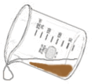
6. The process used in the diagram to the right is called:

(a) filtration.
(b) evaporation.
(c) decanting.
(d) boiling.

7. The best method of separating sand and rice would be:
(a) filtration.
(b) evaporation.
(c) decanting.
(d) sieving.

8. To separate sand and water you could use:

(a) filtration.
(b) evaporation.
(c) decanting.
(d) any of the above

9. Which of the following is not a type of mixture:

(a) suspension
(b) colloid
(c) solvent
(d) solution

10. Which of the following is a method for separating soluble substances?

(a) filtration.
(b) evaporation.
(c) decanting.
(d) centrifuging.

Short Answer Write the answer to the questions in the spaces provided.

If you run out of space or make a big mistake you can use the back page to rewrite your answer

1. Below is a beaker containing copper sulphate solution.
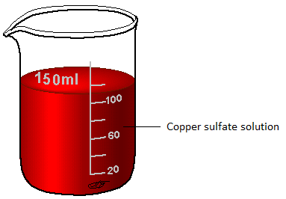

In the beaker above identify the following:

- Solvent
________________________________

- Solute
_______________________________
(2 marks)

2. Match the following types of solutions with the examples in the table below:
a) Solid dissolved in a liquid
b) Liquid dissolved in a liquid
c) Gas dissolved in another gas (3 marks)

Type of Solution | Example
 | Water vapour dissolved in air
 | Cordial dissolved in water
 | Grease dissolved in petrol

3. Draw a concentrated solution and a dilute solution in the images below.

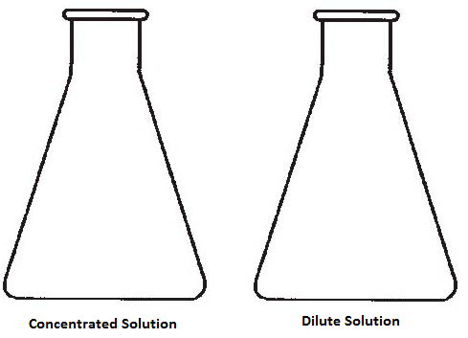
(2 marks)

4. a) Label where you would find the following on the diagram below: (2 marks)
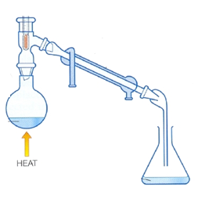
Condensation
Evaporation
Boiling
Solution

b) What method of separation is being carried out by the equipment above? (1 mark)

_______________________________________________________________________________________________________________________________

c) Explain how the equipment shown above could be used for desalination. (3 mark)

_________________________________________________________________________________________________________________________________
___________________________________________________________________________________________________________________________________________________________________________________________________________________________________________________________________________________________________________________________________________________________________________________________________

5. Look at the following table:

Sand | Salt
Sugar | Pebbles
Nescafe coffee | lettuce

Use the information given in the table above to answer the following questions.
- Name two insoluble substances.
_____________________________________________________________________
- Name two soluble substances.
_____________________________________________________________________
- Name one substance that forms a suspension.
_____________________________________________________________________
- Name one substance that dissolves.
_____________________________________________________________________
(6 marks)

6. Use words from the box to complete the sentences below.

Evaporation Distillation Filtration Crystallisation

In the process of _____________________________, liquid passes through a filter, which traps fine grains of solid. In the process of ______________________, heat is used to remove liquid from a solution. ___________________________ is a process that uses heat to remove the liquid from a solution slowly, leaving crystals. The method used to separate the liquid part of a mixture by evaporating the solvent, collecting it and then condensing it to form a liquid again is called _______________.
- marks)

7. A beaker of muddy water was known to contain dissolved salt and some suspended materials (very small solid particles that have not settled to the bottom). If you wanted to recover a sample of the salt on its own you would:
- evaporate first and then filter
- decant first and then re-dissolve
- decant first and then filter
- filter first and then evaporate (1 mark)

Explain why the other choices would not have been suitable.
__________________________________________________________________________________________________________________________________________________________________________________________________________________________________________________________________________________________________________________________________________________________________________________
(2 marks)
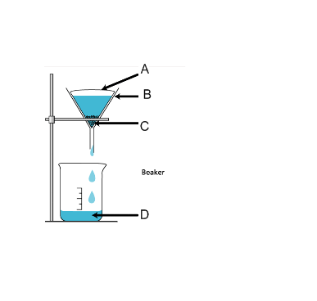
8. Look at the diagram below and match the letters to
their correct name:

filtrate A
residue B
filter paper C
funnel D

(2 marks) ________________________________________________________________________________________________________________________________________________________________________________________________________________________________________________

9a) One of the test tubes below contains a solution, the other a suspension. Label them correctly. (2 marks)

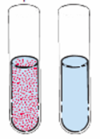

b) Which one of these could be separated using a filter, or could both? (1 mark)
_____________________________________________________________________________________________________________________

10. Complete the table below.

Separation Method | Example from list below | Your own example.

Sieving
Decanting
Distillation
Magnetic Separation
Centrifuging
(5 marks)
List of examples:
- Separating sediment from old wine.
- Separating cream from milk
- Separating sugar from sultanas
- Separating oil products
- Separating iron filings from sand

11. You have been given a mixture of sand, sugar and iron filings. Describe how you could separate the mixture into its three components
________________________________________________________________________________________________________________________________________________________________________________________________________________________________________________________________________________________________________________________________________________________________________________________________________________________________________________________________________________________________________________________________________________________________________________________________________________________________________________________________________________________________________________________________________________________________________________________________________________________________________________________________________________________________________________________________________________________________________________________________________________________________________________________________________________________________
(4 marks)

